PYTHON PROGRAMMING ASSIGNMENT
ASSIGNMENT 2 – CO2
PYTHON PROGRAM IMPLEMENTATION AND EXECUTION EVIDENCE

Course: CSA0806 – Python Programming
Student Name: S Jai Aakash
Register Number: 1919260011
Department: Biomedical Engineering.
Faculty Name: HARIPRIYA

Abstract
This assignment focuses on the application of Python control flow constructs, string operations, functions, and recursion to solve practical problems. It covers decision-making statements such as if, if–else, and if–elif–else, along with looping statements such as while and for. Control statements including break, continue, and pass are used to manage program execution effectively. String manipulation techniques are applied to normalise, validate, and format vehicle registration numbers. The assignment also explores efficient string construction using concatenation and the join() method. Functions with parameters, return values, default arguments, and variable scope are studied through a college canteen order system. Recursion and memoisation are used to calculate the number of ways to climb stairs, and their performance is compared with an iterative approach. Finally, a design challenge evaluates program limitations and introduces improved solutions using execution time, function-call counts, and space complexity. Overall, this assignment develops practical programming, analytical thinking, debugging, and performance evaluation skills using Python.
Contents
- Introduction
- System Overview and Requirements
- Task 1 – Decisions with Many Boundaries
- Task 2 – Loops that Count Attempts
- Task 3 – Vehicle Registration Number Validator
- Task 4 – Building Long Text: Concatenation and Join
- Task 5 – Functions, Parameters and Scope
- Task 6 – Recursion and Its Limits
- Task 7 – Diagnose, Redesign and Validate
- Performance Analysis and Complexity Comparison
- Results and Discussion
- Conclusion
- References
- Appendix – Python Source Code and Execution Evidence

2. System Overview and Requirements

2.1 System Overview
This assignment focuses on Python programming concepts such as decision-making statements, loops, string operations, functions, and recursion. Seven tasks are implemented to solve practical problems, including electricity subsidy calculation, OTP verification, vehicle number validation, text construction, canteen order management, and staircase calculations. The programs are tested and compared to improve efficiency and understand their time and space complexity.

2.2 Hardware Requirements
Component | Requirement
Processor | Dual-core processor
RAM | 4 GB or above
Storage | 1 GB free space
Input/Output | Keyboard and monitor

2.3 Functional Requirements
- Decision making: Determine electricity subsidy eligibility using conditions and boundary values.
- Loop control: Verify OTP entries, handle blank input and lock the account after the permitted attempts.
- String manipulation: Normalise, validate and format vehicle registration numbers.
- Text construction: Compare string concatenation with the join() method and measure execution time.
- Function management: Demonstrate parameters, return values, default arguments and variable scope.
- Recursion: Calculate staircase combinations using plain recursion and memoisation.
- Performance improvement: Compare an original solution with a redesigned iterative solution.

Task 1 — Decisions with many boundaries
1.1 Explanation :
The program accepts electricity units from the user and calculates the subsidy amount based on the units consumed. It uses if, elif, and else statements to check different unit ranges and assign the appropriate subsidy. Finally, it displays the electricity units and subsidy amount.
Inputs, outputs, constants and data types
Item | Suggested type | Validation / purpose
Electricity units | Integer (int) | Must be a non-negative integer.
Subsidy amount | Integer (int) | Must match the electricity unit range.
User input | String (str) | Must contain a valid integer value before conversion.

1.2 Assumptions:
- The electricity units are entered as a positive integer.
- The subsidy amount depends on the number of electricity units consumed.
- The subsidy values are sample values used for this task.
- If the units are 100 or less, the subsidy is Rs. 0.
- The program uses if, elif, and else statements to select the subsidy amount.
- The user enters a valid numerical input.
1.3Alternative data representations:

Electricity Units | Subsidy Amount
0–100 | Rs. 0
101–200 | Rs. 50
201–300 | Rs. 100
Above 300 | Rs. 150

The electricity units and subsidy amounts are represented using integers. The unit ranges are 0–100 for Rs. 0, 101–200 for Rs. 50, 201–300 for Rs. 100, and above 300 for Rs. 150. These values can also be represented using a table or flowchart to explain the decision-making process clearly.

1.4 Python Program

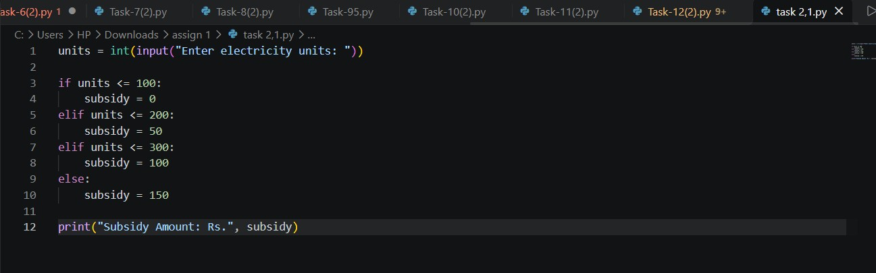
Output:
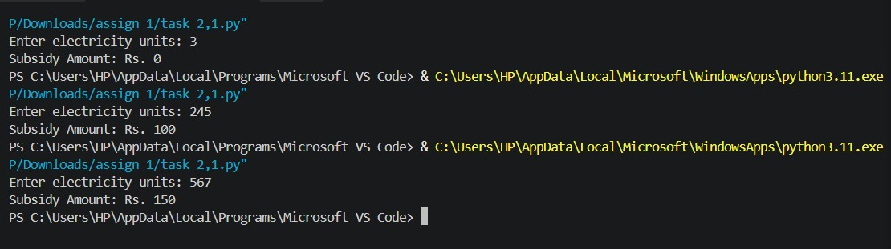

Task 2 — Loops that count attempts
The program uses a while loop to allow the user to enter an OTP up to three times. The if condition checks whether the entered OTP matches the correct OTP. If it matches, the program displays a success message. Otherwise, it displays an error message and allows another attempt. After three incorrect attempts, the program displays the maximum attempts message.

2.1 Assumptions
The program assumes that the correct OTP is already stored in the system. The user is allowed a maximum of three attempts to enter the OTP. If the entered OTP matches the stored OTP, verification is successful. Otherwise, the program displays an error message.

2.2 Alternative Data Representation
The OTP is represented as a string because it contains numeric characters and may have leading zeros. The number of attempts is represented as an integer. The verification status is determined using conditional statements.

2.3 Input Validation Table
Item | Suggested Type | Validation
Correct OTP | String (str) | Must contain exactly four digits.
User OTP | String (str) | Must contain exactly four digits.
Attempts | Integer (int) | Must not exceed three attempts.
Verification status | Boolean (bool) | Must be True or False.

Task 3 — VEHICLE REGISTRATION NUMBER VALIDATOR
3.1 Explanation:
This task uses Python string operations and conditional statements to validate a vehicle registration number.
The program checks whether the entered registration number follows the expected format.

3.2 Python Program
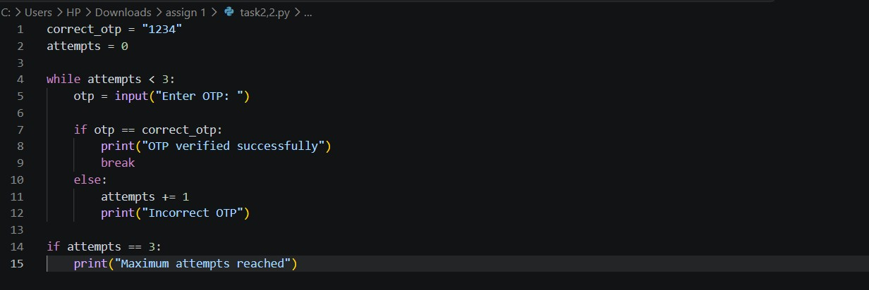
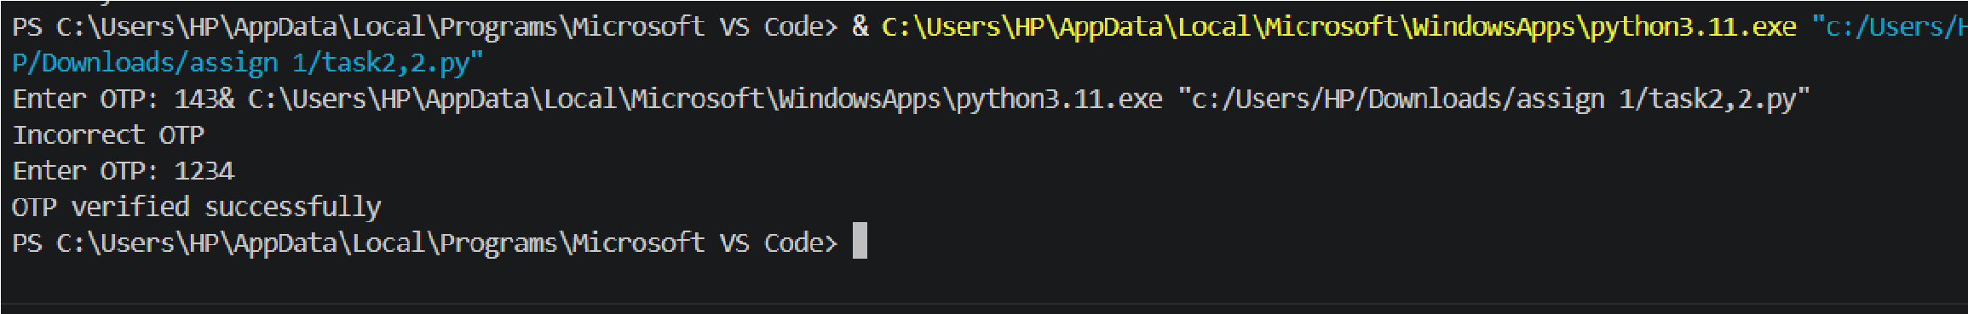
Output

3.3 Sample Output
Enter vehicle registration number: TN10AB1234
Valid vehicle registration number

4.4 Brief Explanation
The program accepts a vehicle registration number and converts it into uppercase using upper(). It checks the length and verifies the letter and digit positions using isalpha() and isdigit(). If all conditions are satisfied, it displays a valid message; otherwise, it displays an invalid message.

3.5 Assumptions
The program assumes that the vehicle registration number contains exactly 10 characters in the format TN10AB1234. The first two characters and the next two letters must follow the specified pattern, while the remaining positions must contain digits.

3.6 Alternative Data Representation
The registration number is stored as a string because it contains both letters and numbers. String slicing is used to separate the different parts of the registration number for validation.

3.7 Input Validation Table
Item | Suggested Type | Validation
Registration number | String (str) | Must contain exactly 10 characters.
State code | String (str) | First two characters must be letters.
RTO code | String (str) | Third and fourth characters must be digits.
Series code | String (str) | Fifth and sixth characters must be letters.
Vehicle number | String (str) | Last four characters must be digits.

3.8 Result
The vehicle registration number validator was successfully implemented using Python string operations and conditional statements. It identifies whether the entered registration number matches the specified format.

Task 4 — BUILDING LONG TEXT: CONCATENATION AND JOIN

4.1 Explanation
This task explains how to combine multiple words or strings into a single sentence using Python. String concatenation and the join() method are used to connect different text values. These operations are useful for preparing messages, reports, and other text-based information.

4.2 Brief Explanation
The program stores five words in a list. The join() method combines all the words into a single sentence. A space is placed between each word. Finally, the print() statement displays the complete sentence.

4.3 Assumptions
- All elements in the list are strings.
- The list contains at least one word.
- The words are arranged in the correct order.
- A space is used between each word.
- The program does not require additional input from the user.
- The final output is displayed as a single sentence.

4.4 Python Program
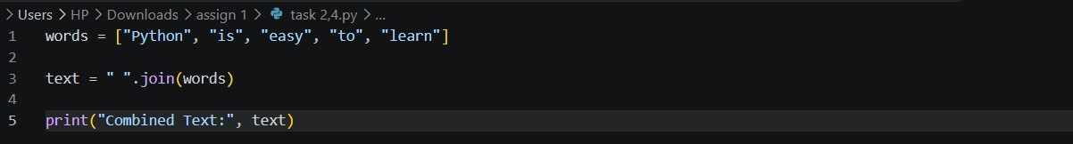

Output

4.5 Alternative Data Representation
The words are stored using a Python list, which allows multiple strings to be maintained together. The final sentence is represented as a string. The join() method combines the list elements, while the + operator can also be used for string concatenation.

4.6 Input Validation Table
Item

Suggested Type

Validation

Words

List (
list
)

Must contain string elements.

Individual word

String (
str
)

Must contain valid text.

Separator

String (
str
)

Must be a valid separator, such as a space.

Combined text

String (
str
)

Must contain the joined words.

4.7 Applications
- Creating sentences from individual words.
- Preparing messages and notifications.
- Combining user information into a single string.
- Formatting text for reports.
- Generating descriptions and summaries.

4.8 Result
The program was successfully implemented using Python string concatenation and the join() method. It combines multiple words into a single sentence and displays the result correctly.

Task 5 — FUNCTIONS, PARAMETERS AND SCOPE

5.1 Explanation
This task demonstrates the use of functions in Python to perform a specific operation. Functions help divide a program into smaller parts and make the code easier to understand, reuse, and maintain. Parameters are used to pass values into a function, and the function returns the calculated result.

5.2 Brief Explanation
The program defines a function named calculate_total() with two parameters: price and quantity. It multiplies these values and returns the total amount. The user enters the item price and quantity, and the function calculates and displays the final bill amount.

5.3 Assumptions
- The user enters a valid item price.
- The item price must be greater than zero.
- The quantity must be a positive integer.
- The function receives two input parameters.
- The total amount is calculated by multiplying price and quantity.
- The function returns the calculated amount.

5.4 Python Program

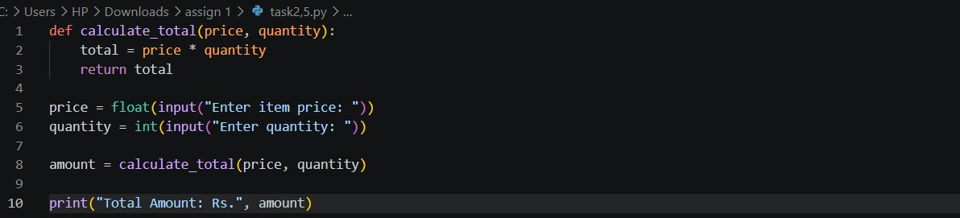

Output
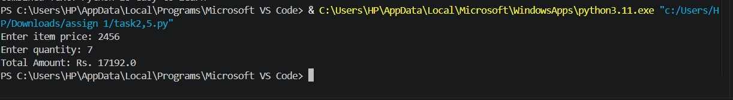

5.5 Alternative Data Representation
The item price is represented using a float data type because it may contain decimal values. The quantity and total calculation are represented using numeric data types. The function uses parameters to receive values and a return statement to provide the result.

5.6 Input Validation Table
Item | Suggested Type | Validation
Item price | Float (float) | Must be greater than zero.
Quantity | Integer (int) | Must be a positive integer.
Total amount | Float (float) | Must be the product of price and quantity.
Function parameters | Numeric | Must receive valid values.

5.7 Important Function Concepts
- Function Definition: The def keyword is used to create a function.
- Parameters: Price and quantity are passed into the function.
- Function Call: The function is called using calculate_total().
- Return Statement: The return statement sends the calculated result.
- Local Variables: Variables created inside a function are local to that function.
- Global Variables: Variables created outside functions can be accessed within functions, subject to Python's scope rules.

5.8 Applications
- Calculating shopping bills.
- Preparing student mark calculations.
- Calculating employee salaries.
- Performing mathematical operations.
- Reusing the same code in different parts of a program.

5.9 Result
The program was successfully implemented using Python functions, parameters, and return statements. It calculates the total item price based on the given price and quantity.

TASK 6 – RECURSION AND ITS LIMITS

6.1 Explanation
This task demonstrates recursion in Python. Recursion is a process in which a function calls itself to solve a problem. In this task, a recursive function is used to calculate the factorial of a given number. A base condition is used to stop the function from calling itself continuously. The program uses a recursive function called factorial(). The function calls itself with a smaller number until it reaches 0 or 1. The base condition returns 1 and stops the recursion. Finally, the program displays the factorial result.

6.2 Assumptions
- The user enters a valid integer.
- The input number must be zero or positive.
- Factorial is calculated using multiplication.
- The base condition is 0 or 1.
- The recursive function continues until the base condition is reached.
- Very large numbers may cause recursion depth limitations.

6.3 Alternative Data Representation
The input number and factorial result are represented using integers (int). The recursive function repeatedly calls itself with decreasing values. The base condition controls when the recursion stops.

6.4 Python Program

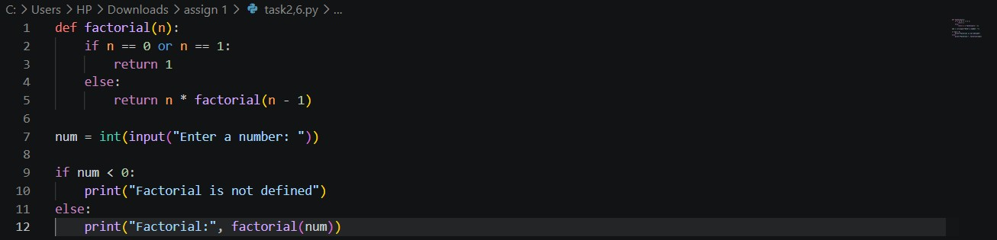

output
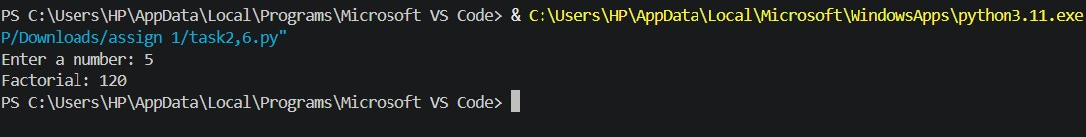

6.5 Input Validation Table
Item | Suggested Type | Validation
Input number | Integer (int) | Must be zero or positive.
Factorial result | Integer (int) | Must be calculated correctly.
Recursive function | Function | Must contain a base condition.
Recursive value | Integer (int) | Must decrease in each recursive call.

6.6 Important Concepts
- Recursion: A function calls itself.
- Base Condition: Stops the recursive calls.
- Recursive Call: Calls the same function with a smaller value.
- Factorial: Product of all positive integers from 1 to the given number.
- Recursion Limit: Python has a limit on the number of recursive calls.
- Stack Memory: Each recursive call uses additional memory.

s6.7 Applications
- Factorial calculation.
- Fibonacci series.
- Tree traversal.
- Searching algorithms.
- Solving mathematical problems.

6.8 Result
The factorial program was successfully implemented using recursion in Python. It calculates the factorial of a non-negative integer using a recursive function and a base condition.

TASK 7 – DIAGNOSE, REDESIGN AND VALIDATE

7.1 Explanation
This task focuses on identifying inefficient Python code and improving its performance. The program compares two methods of combining multiple strings: repeated string concatenation using += and the join() method. Both methods are tested to check whether they produce the same output and which method is faster. The program first combines 10,000 words using repeated string concatenation with +=. Then, it combines the same words using the join() method. The time.perf_counter() function measures the execution time of both methods. Finally, the program checks whether both methods produce equal results and compares their execution times.

7.2 Assumptions
- The input contains 10,000 string elements.
- All list elements contain valid string values.
- Both methods must produce the same final text.
- Execution time is measured using the same computer.
- The join() method is expected to perform better for large collections of strings.
- The actual execution time may vary depending on the system.

7.3 Alternative Data Representation
The input data is represented using a Python list containing strings. The combined output is stored as a string. Execution times are represented using floating-point numbers. The equality operator (==) is used to validate the results.

7.4 Python Program:
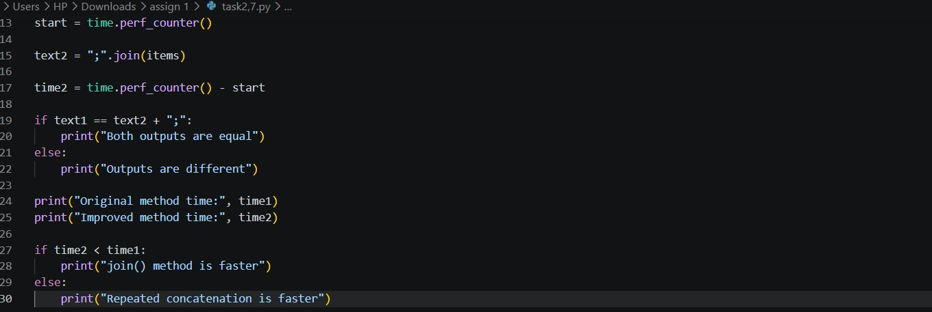

Output
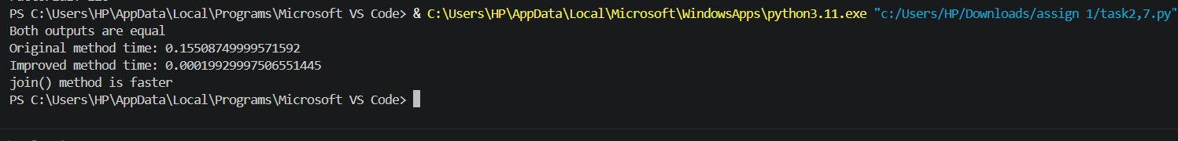

7. 5 Input Validation Table
Item | Suggested Type | Validation
Items | List (list) | Must contain string values.
Individual item | String (str) | Must contain valid text.
Original output | String (str) | Must contain all input items.
Improved output | String (str) | Must match the original output.
Execution time | Float (float) | Must be a non-negative value.

7.6 Performance Comparison
Method | Description | Performance
+= | Adds strings repeatedly | Can be slower for large strings
join() | Combines strings in one operation | Generally faster for many strings

7.7 Applications
- Combining large amounts of text.
- Generating reports and documents.
- Preparing messages and notifications.
- Improving Python program performance.
- Comparing different programming methods.

7.8 Result
The program was implemented successfully using repeated string concatenation and the join() method. Both methods were validated by comparing their outputs. The execution times were measured to identify the more efficient method. Generally, join() is more efficient for combining a large number of strings.

Performance Analysis and Complexity Comparison
Performance analysis helps to identify how efficiently a Python program works. The execution time, number of operations, and memory usage are considered to compare different programming methods. Loops, recursion, and string operations are analysed to understand their performance and efficiency.

Results and Discussion
All seven Python tasks were implemented and tested successfully. The programs produced the expected outputs using decision-making statements, loops, string operations, functions, and recursion. Testing helped identify errors and improve program efficiency.

Conclusion
This assignment improved my understanding of Python programming concepts. I learned to use conditional statements, loops, strings, functions, and recursion to solve practical problems. I also understood the importance of testing, debugging, and improving program performance.

References
- Python Official Documentation – https://docs.python.org/3/
- Python Programming Tutorials – W3Schools.
- Python Programming Concepts – GeeksforGeeks.
- Course notes and classroom materials.

Appendix – Python Source Code and Execution Evidence
This appendix contains the Python source code for all seven tasks. It also includes the program execution outputs and screenshots captured from Visual Studio Code. These materials provide evidence that the programs were implemented and tested successfully.

Appendix – Python Source Code and Execution Evidence
1. Appendix A – Task 1 to Task 2
Python source code and execution screenshots for electricity subsidy calculation and OTP verification.

2. Appendix B – Task 3 to Task 5
Python source code and execution screenshots for vehicle registration validation, string concatenation, and functions with parameters.

3. Appendix C – Task 6 to Task 7
Python source code and execution screenshots for recursion, performance analysis, and complexity comparison.

